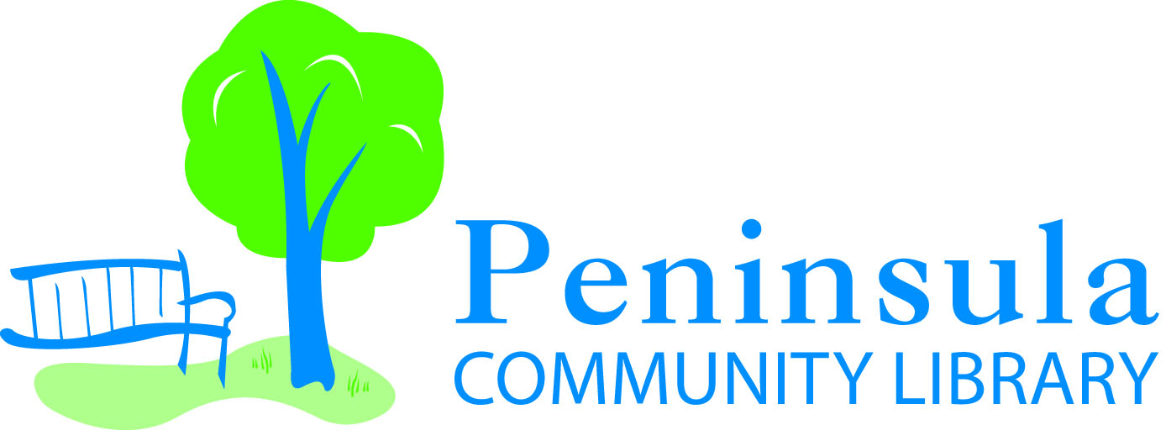

Committee Meeting – Policy
Thursday June 9, 2022 at 4:15 pm
Members present:
Public comment
Discussion change to patron conduct policy
Public comment
Adjournment

2893 Island View Road
Traverse City, MI 49686
231-223-7700

