A beautiful vintage Signature Quilt made in 1892, usually at home in the Old
Mission Dougherty Rushmore house, is now on display in the Community Room
at the Peninsula Community Library. We invite you in to see it. It is the story of a quilt, a family and a church – all a part of our shared Old Mission heritage!
The quilt is on loan from the Archer/Sargent/ VanBrocklin Family.
The Signature Quilt
By Connie Archer Sargent (2/2024)
THE QUILT:
Friendship quilts (or Signature quilts) originated on the east coast around the 1840s – 1850s.
They were made up of single squares where one could sign their name. Originally these were
signed with ink, but later the signature would be signed and embroidered with Turkey Red
work thread (more later). The squares would be sewn together to make a quilt. These squares
imitated many of the small signature albums that were popular at the time, where friends, family or
classmates would sign their name on a page and perhaps draw a design.
These types of quilts eventually lost favor out East, but grew in popularity
in the Midwest in the 1880s and 1890s as people moved westward. Frequently these
were given as gifts to newlyweds, special community members, and to celebrate milestones.
Quilts were shared with those moving further out west, knowing they would seldom return home.
There are also reports of quilts being sent to missionaries and to raise money for war veterans.
Because they were designed, organized and put together by women, they frequently had
women’s signatures, but this quilt on display includes both women and men’s names.

The squares could be sold for a few pennies and used as a money maker for an
organization such as a church or a social group, in this case the Ladies Aid
Society. These quilts would be further divided by quilter historians into Album
Quilts, Signature or Friendship Quilts with many different subcategories. This particular quilt
was entered into two quilt shows as a vintage quilt by my mother (Nellie Archer) in
Traverse City many years ago. Sometimes these quilts would have a signature,
and many would include fancy designs that would be embroidered onto the
square. This quilt has several examples of this. These designs were so
popular that companies even made traceable designs out of them.
Well-known names that can be seen on the quilt are Edgecomb, Fowler, Helfrich,
Holman, Jamieson, Johnston, Kroupa, Lardie, Marshall, Tompkins, Wilson and more.
A list of names is attached. The display at the library includes a framed list of the names on the quilt.
Some names were hard to read so if a mistake was made, please let me know.

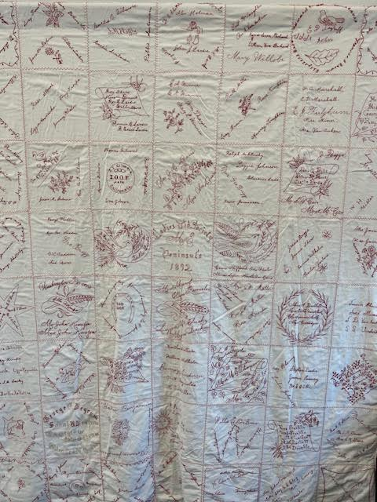

Included in the names of local residents are a few people from Fife Lake and family
members that did not live here (my great uncle).
The deep red thread used on this quilt is called Turkey Red. It was the first thread
that was colorfast and was frequently used to embroider towels, sashes, napkins,
dresser scarves, sofa pillows and later bed covers. Their popularity had
designers making a variety of designs for children, and decorative designs for
the home. The cost was higher, as it was the first thread made that did not fade.
In 1910, a new color blue was introduced that had these properties. The Dougherty
Rushmore house has on display some tea towels with this Turkey Redwork thread.

MY FAMILY:
The Gilmores were living here in 1892 when this quilt was made. Among the relatives
mentioned on this quilt were my great grandparents, Thomas and
Mary Jane Gilmore. They came from Ireland to New York where they resided for a few
years, before moving to Old Mission Peninsula in 1882. They had 11 children, 7
boys and 4 girls, 2 of which died under the age of one. On a letter recording the family
history, it is reported they lived in a small shingle-covered log house that had been built
by a Mr. William Ayers. This is verified by plat map (1856—1861) that “Willis S. Ayers”
owned the land just south of 2 Lads, where there is an open field. They came to Old Mission
with their children and among them was their fourth son, my grandfather, Miles Gilmore.

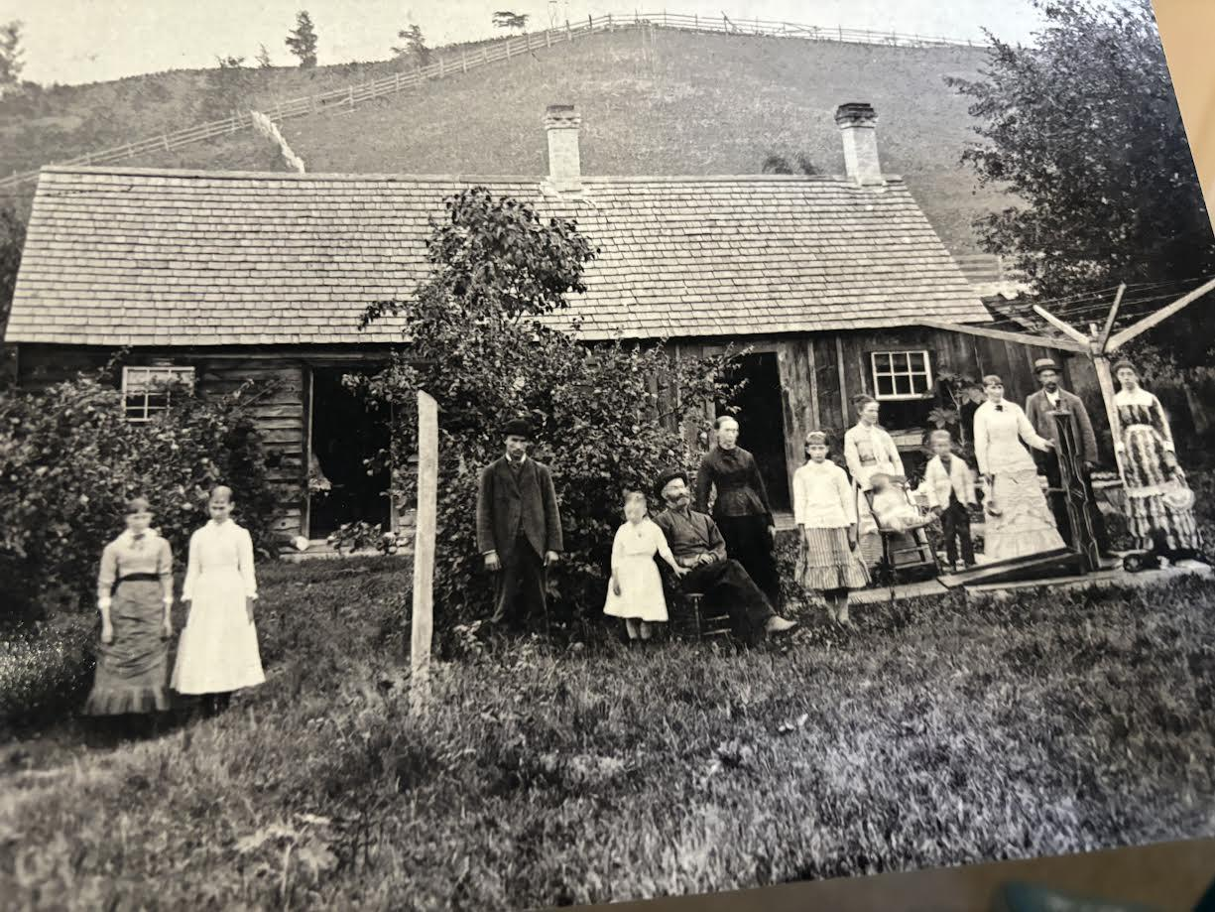
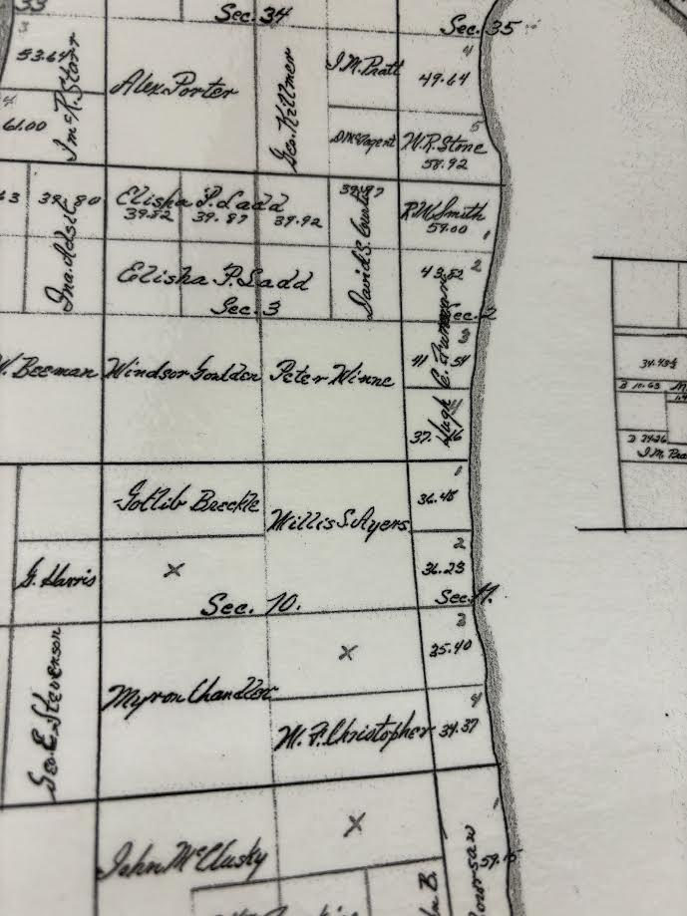

In 1888, Thomas built a new residence just up the hill, a white house that is
on the north side of the steep hill on Smokey Hollow, between Smokey Ridge and
Whispering Pines, north of Ladd Road. The Grand Traverse Herald reported the
housewarming to have been an outstanding success, as some thirty young people
joined to celebrate the occasion, dancing to music by John Dohm.

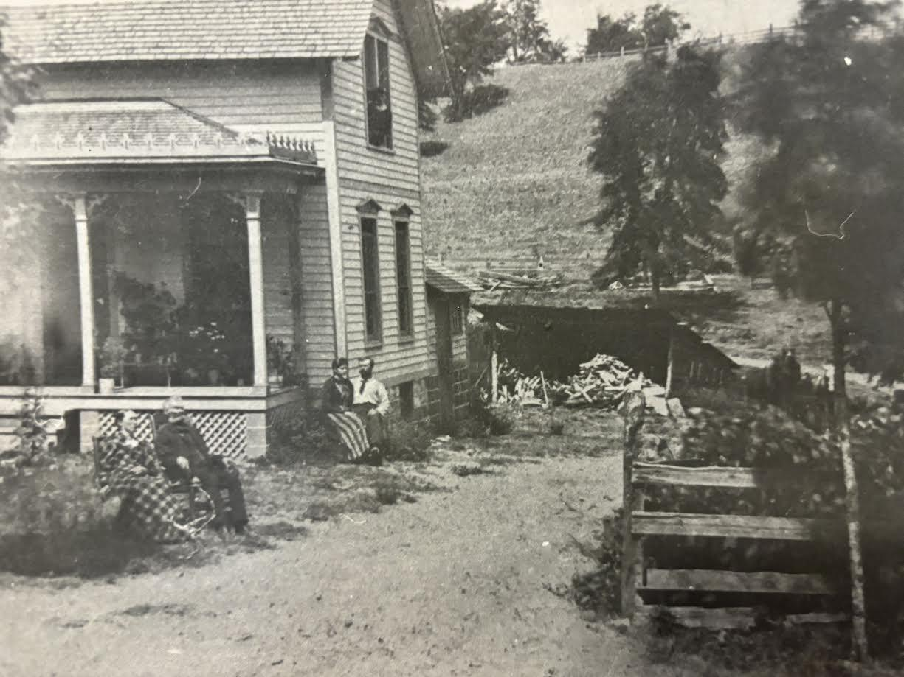
The Gilmores purchased 80 plus acres on Center Road where they farmed. This
was across from the present-day location of Old Mission Flowers. My grandfather
Miles Gilmore, married my grandmother, Bertha Marshall after his first wife passed
away. He built a large home on the corner of Ladd and Center Road, which is presently
owned by Lou and Ginny Couture.
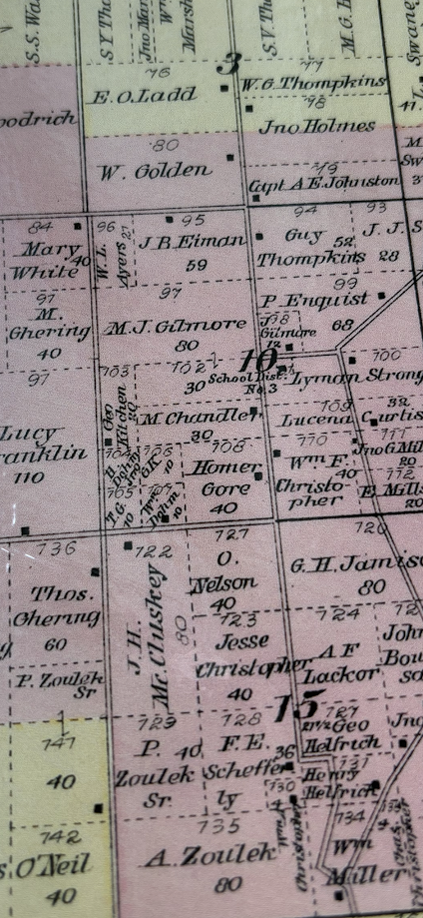
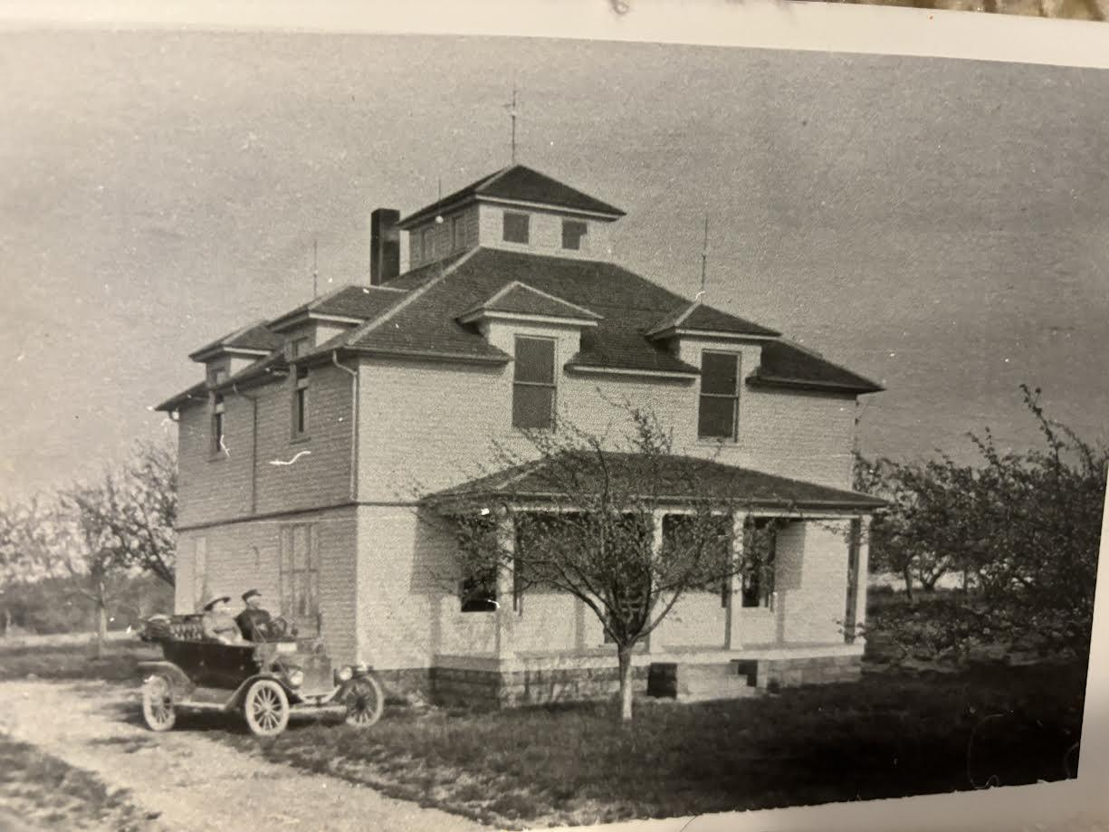

One of the names on a square of the quilt was my great uncle, Joseph Irving (J.I.)
Gilmore, and there was a circle with his name and the initials I.O.O.F - Napa,
California. Research led me to find out that he had moved to California and
was a member of the International Order of Odd Fellows. This organization provided
a helping hand to those in need, and supported the men coming back from wars
and their families. During this time there was very little government assistance.

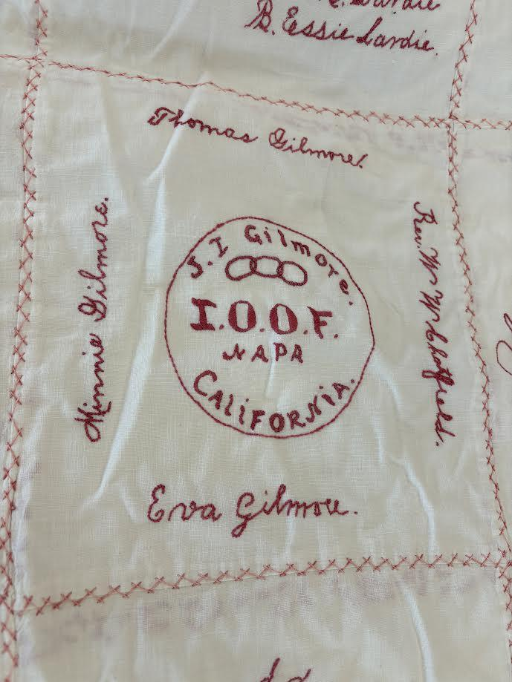

According to the book, Odd Fellows: Rediscovering More Than 200 Years of History,
Traditions and Community Service by Louie Blake Saile Sarmiento (2019),
“The Odd Fellows were the forerunners of homes for the aged and
orphanages. They are also the predecessors of the Social Security System
and National Health Insurance. At that time, Odd Fellows literally touched
the lives of millions of people, following its tenets to “visit the sick, relieve
the distressed, bury the dead, and educate the orphan.”

My grandfather, Miles Gilmore passed away in 1922 when my mother and her
brother, Miles Gilmore were very young. This was a hardship for my grandmother
(Bertha Gilmore) to maintain an 80-acre farm with two young children. My grandmother
had to sell the farm and move into Traverse City until a house was purchased on
Mission School Road, where my mother and her brother enjoyed many glorious
summers. This area is very dear to me, as it was very dear to my family.
In fact, the land for the replica log church was donated by my grandmother
(Bertha Gilmore), so that the Township could build the replica log church.
My mother, Nellie Gilmore, married and became Nellie
(Verlo) Archer and my parents inherited the property from her cousin, Jessie
Gilmore Hicks, on Swaney Road where I now live.

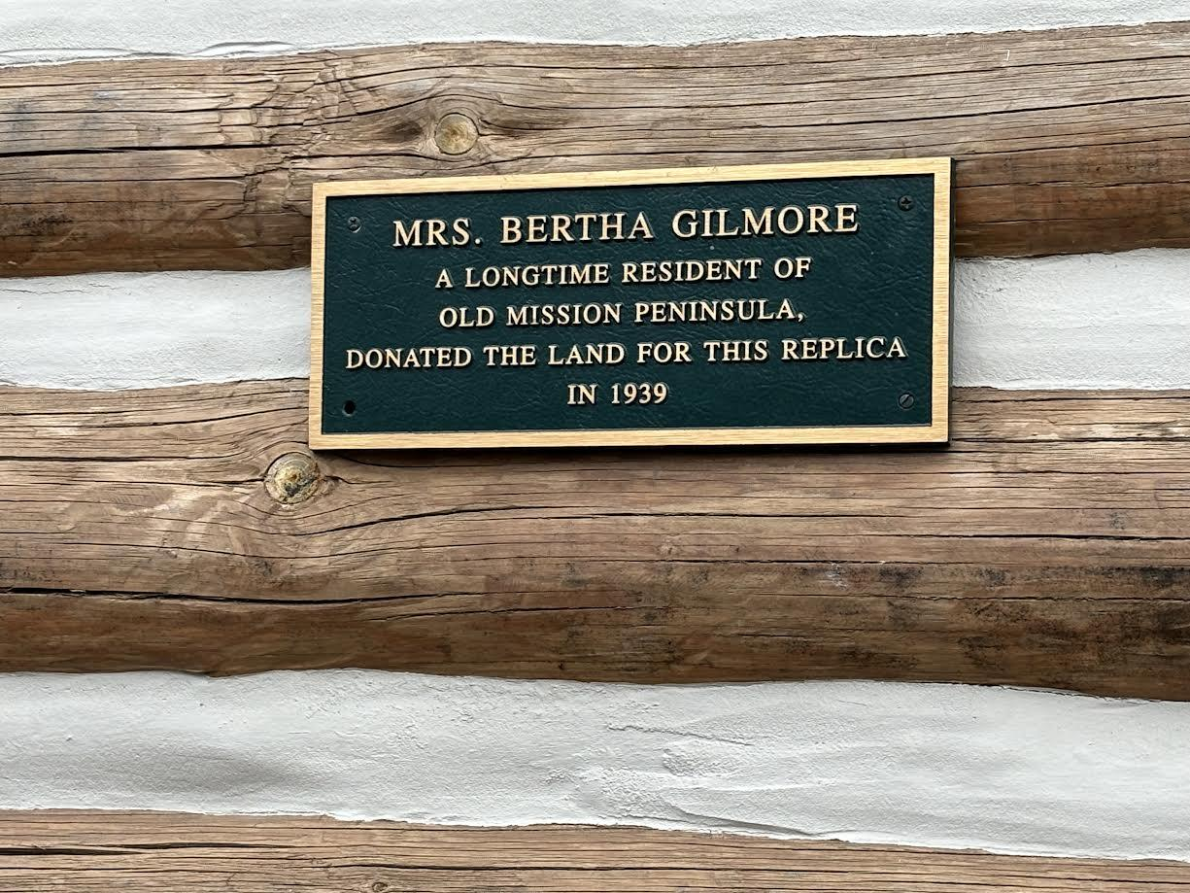

I began to track how the quilt came into our family, which led me to
research the Gilmore genealogy, which I continue today. I know it was
given to my mother by Jessie Gilmore Hicks, her cousin and the youngest
daughter of Andrew and Estella Gilmore, who grew up on Old Mission Peninsula.
Jessie later moved to California where she met her husband (Arthur Hicks) who
served in the Army. She had 2 uncles and a favorite aunt (my grandfather’s siblings)
who had also moved to California. After Arthur ‘s retirement from the Army,
they purchased land in Old Mission on Swaney Road. I believe Jessie got the quilt
from her favorite aunt, Jessie Gilmore Tatman. But that leaves me to question where
her Aunt Jessie got it from. Perhaps one of her brothers who had previously
moved to California had received it as a going away gift. The quilt is currently on display at the
Peninsula Community Library and will eventually return to the Dougherty House.
There is a lesson here: Ask your parents and grandparents many questions while they are
still alive - they definitely have stories to tell!

