Friends of PCL  Garden Bricks Order Form | 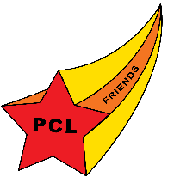

The Friends of Peninsula Community Library will place an annual brick order each year in July and the bricks will be installed in the autumn. Please submit your order by July 31 to be included this year.

- Bricks are 4" x 8" with three lines of engraving for $100.
- Each brick may contain up to three (3) lines of text with up to 18 characters or spaces per line.
- Any symbol is considered one space (Period, Comma, Dash).
- All text will be centered.

Friends of the Peninsula Community Library is a 501(c)(3) organization; therefore, a portion of your donation (less brick value of $25) may be tax deductible. Consult your tax advisor.

Name: ___________________________________________________________________________________

Address: _________________________________________________________________________________

City/State/Zip: _____________________________________________________________________________

Email: ____________________________________________________________________________________

Brick # 1
Brick #2
Brick # 3

Return this form and your check payable to:  Friends of Peninsula Community Library  2893 Island View Road  Traverse City, MI 49686 | Total for Engraved Bricks @ $100 each:  $_____________
Questions? Email: PCL.Friends.bricks@gmail.com or call the library at 231 223-7700

