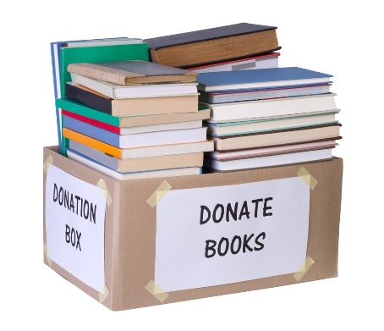

**Sorry...we cannot accep**t:

• Reader’s Digest condensed books

• Encyclopedias

• Magazines (even National Geo)

• VHS tapes

• Bibles and other religious texts

• Textbooks

• Outdated technology manuals

• Outdated medical information

• Items that are dirty, moldy, water damaged or with excessive markings or highlighting.

• Hint! Ask yourself, “Would I buy it?”

Help your PCL Friends by following these Donation Guidelines

**Questions? Call 231 223-7700 or email PCLfriends.omp@gmail.com**

**On first and third Mondays from 4-6 pm**, you may bring your donations to the PCL Carriage House.

Please have the books in **small or medium sized boxes** in your trunk or hatch. Volunteers will be there to assist in getting the books and other materials unloaded and into the Carriage House.

**If you need to arrange for drop-off at a different time**, please contact the Friends of PCL to do so.

**The Friends of PCL accept gently used books, puzzles, DVDs and CDs as part of our fundraising efforts.**